Configuring maven project in Jenkins

Step1) After login your Jenkins Dashboard ,you have to select **NEW ITEM** option from your left pane.

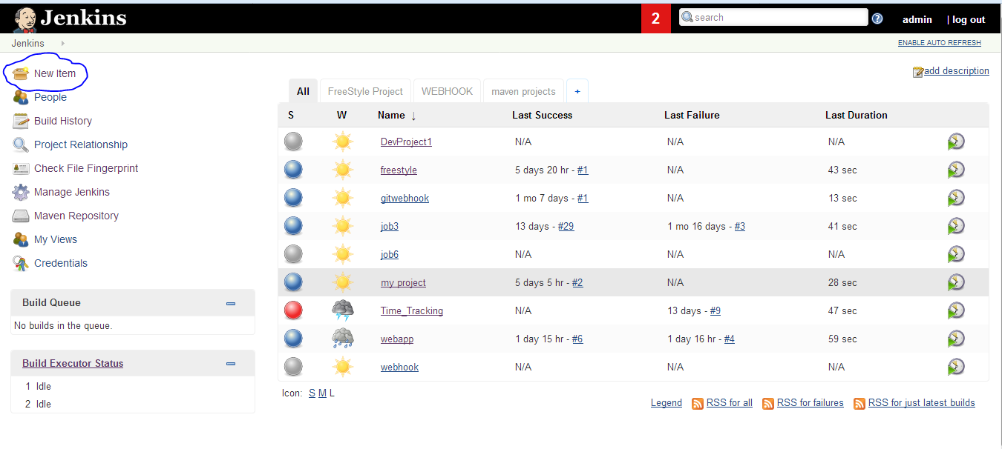

Step2)

Next you need to give your project name and select your project style either Freestyle project or maven project, and next click on ok button.

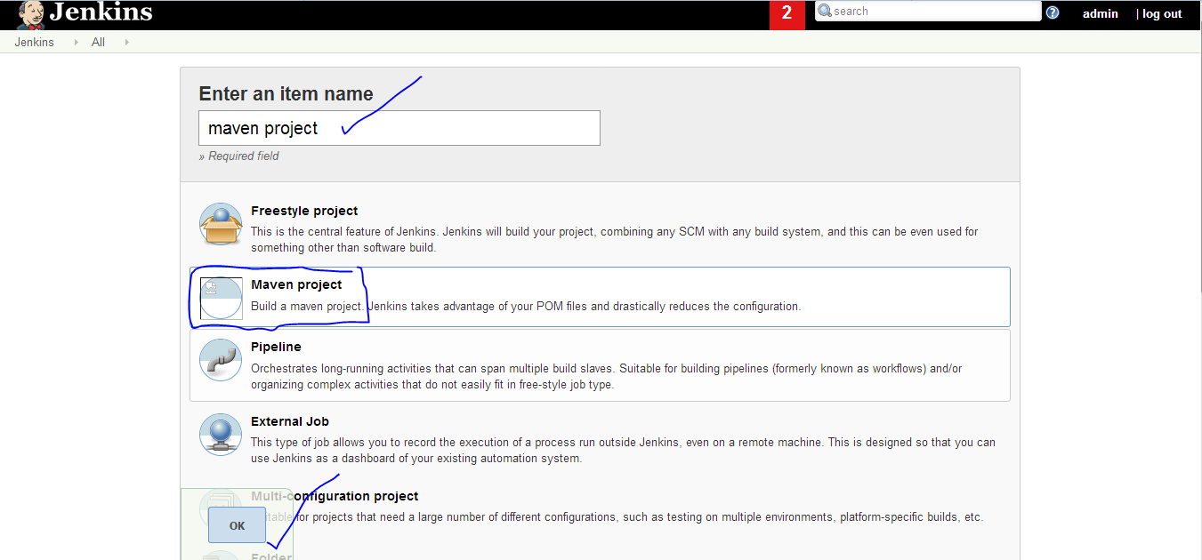

Step 3) Next job configure section will come.

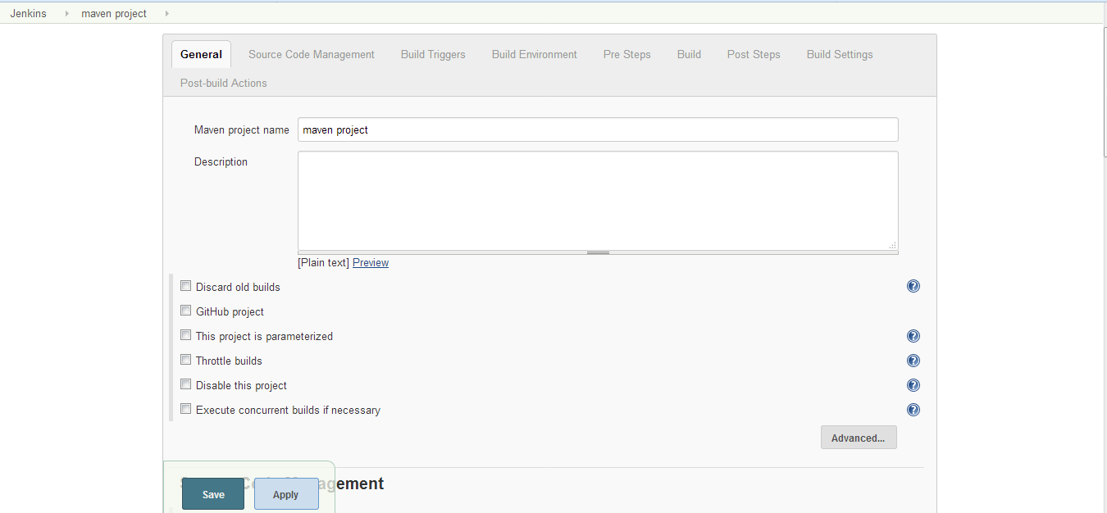

Step4) In **General** tab section you have to select Github project option .

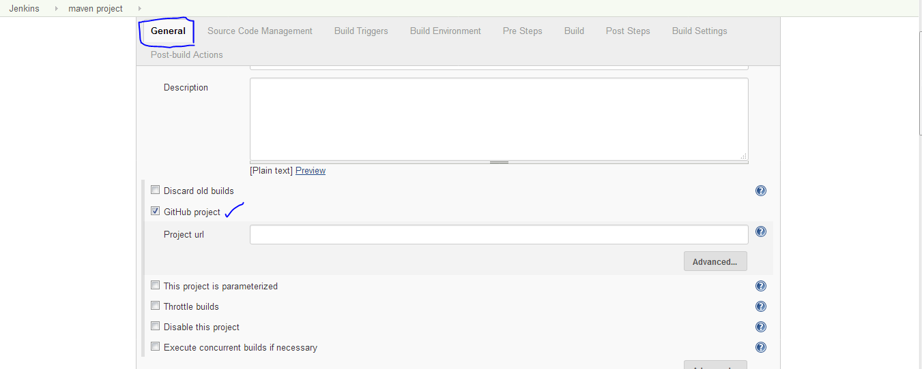

Step5) it will ask Project url .you need to give your project url from github.

Im using simple maven project from my github account.if you want to clone it you can clone from the account [**https://github.com/deepueng40/maven**](https://github.com/deepueng40/maven)

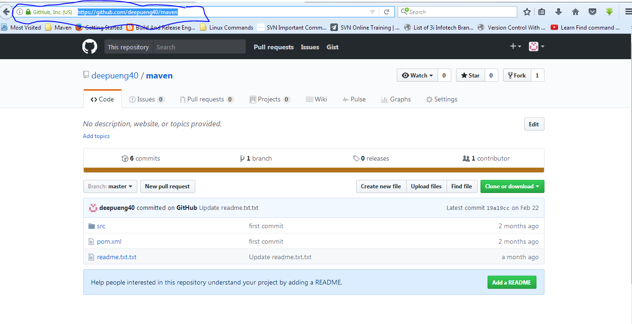

**Step6)**give your project url in project url section.

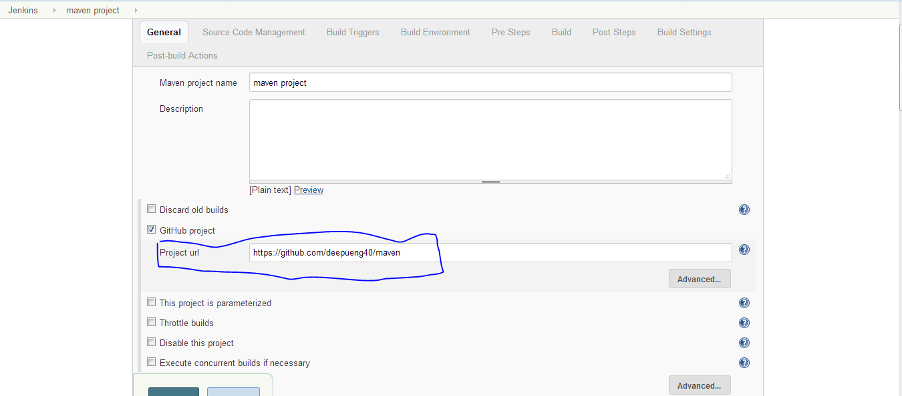

**Step7)** after giving the project url you need to go source code management section .

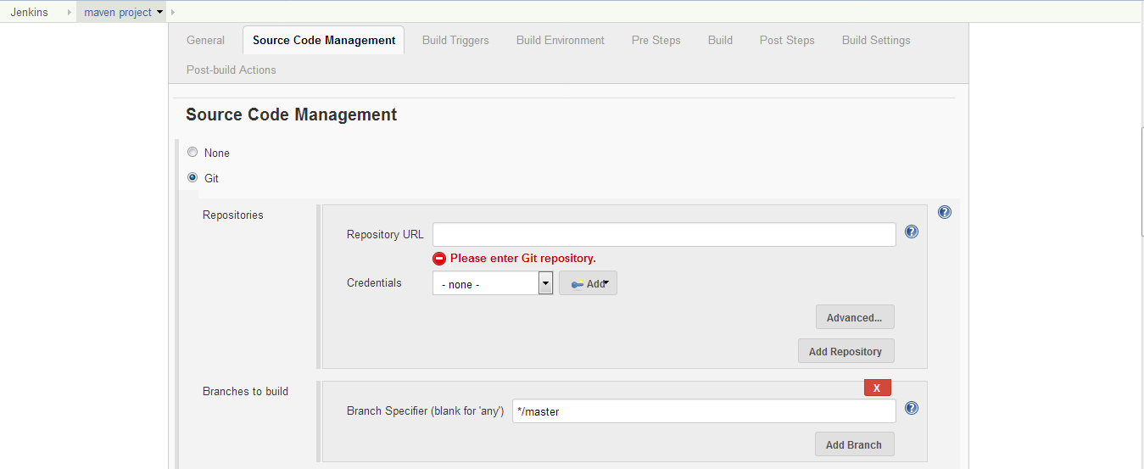

Step8) it will ask you for repository url .from that purpose you need to go your github project and copy the repository url.

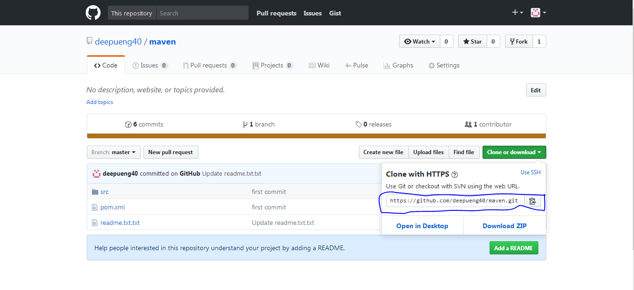

Step9) paste your repository url in the repository url section

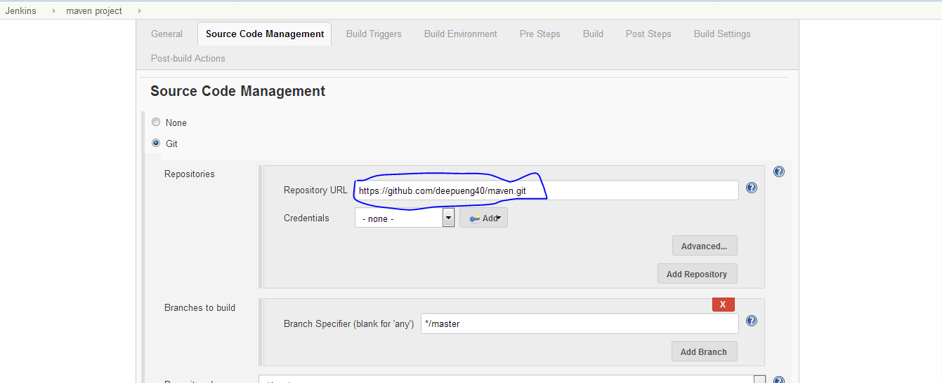

Step10) Next you need to come **build section,** under build section you have to give root pom and Goals and options.

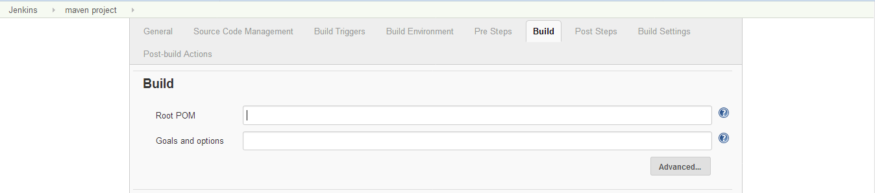

Step11) under root pom field you need to mention pom.xml, IN goals and options field you need to give maven related phases. i mentioned here clean package.(clean package will do firstly it will remove the target folder and compile the code and it will test the code and it will give the artifacts, nothing but binary files(jar,war,Ear)).

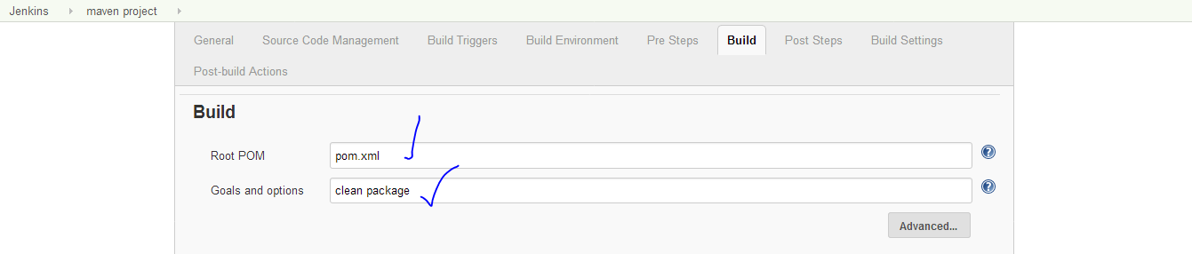

Step12) Then you need to click on save button.

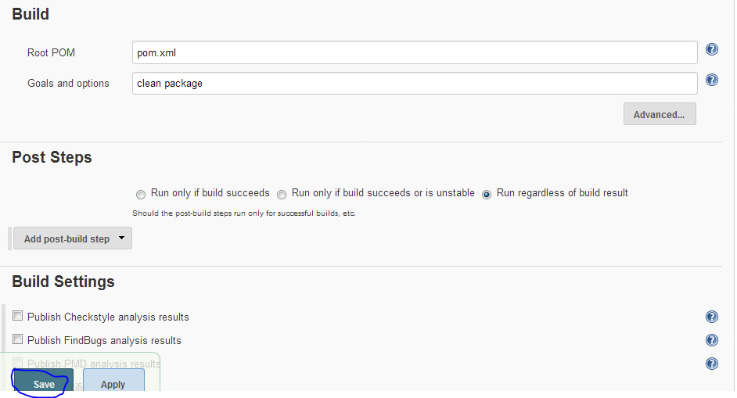

Step 13) if you observe workspace folder for the first time .it does not have any files. if you build the job it will conatin the files.(like class files of your project,test files and war jar files)

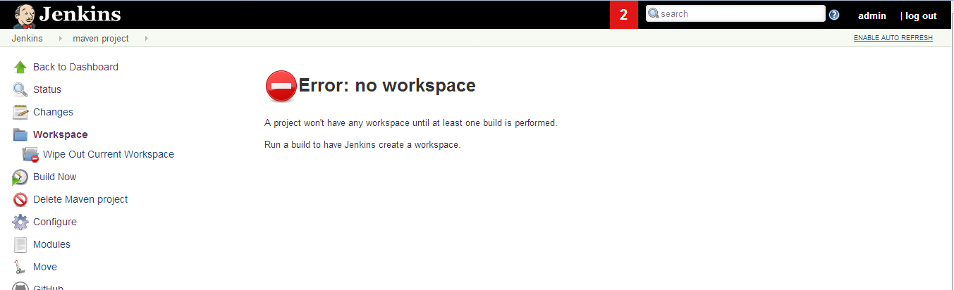

Step14) next click on the build now option from the job dashboard

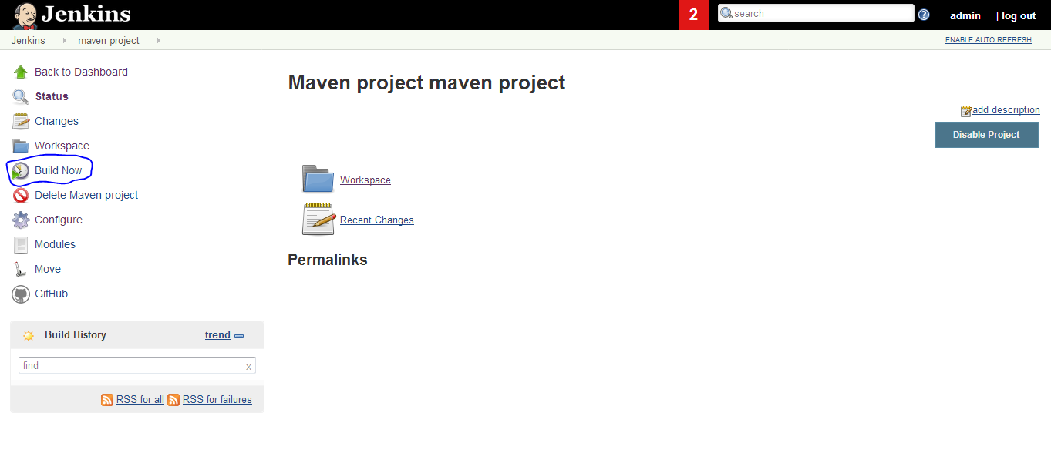

Step15) job suceesfully build

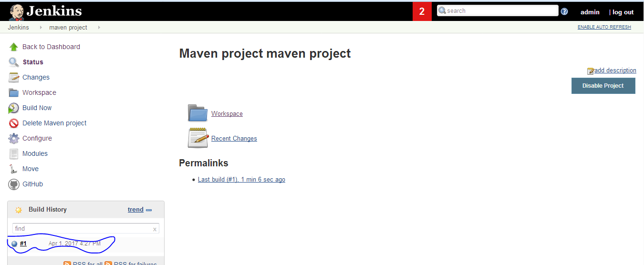

Step16) if you want to see the output of the project go to console out put. 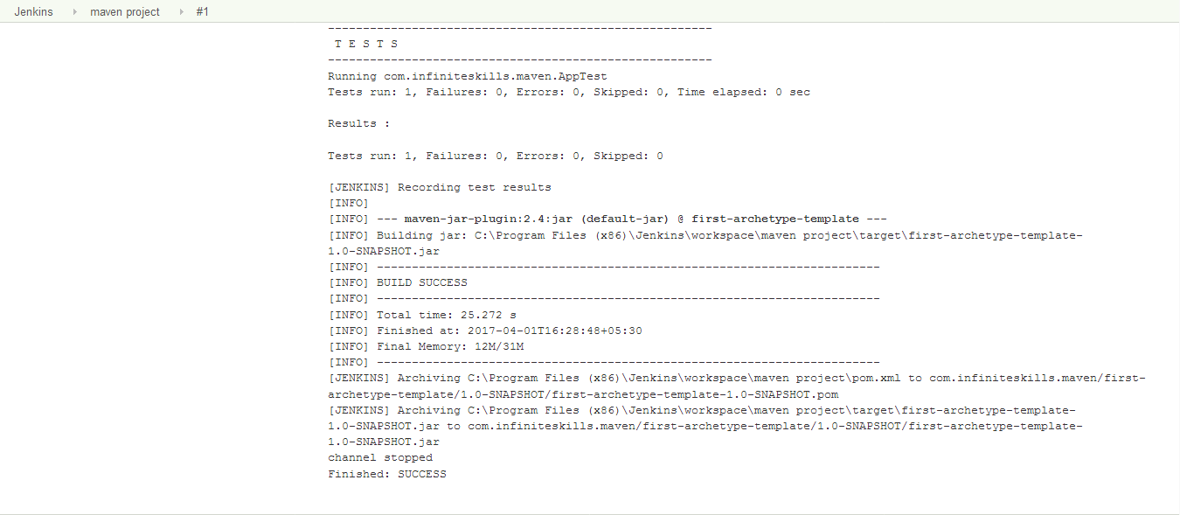

Step17)observe the work space once you will get the class files and artifacts of the project.

